3.1 Setting Up Jenkins 



This section will guide you to:

* Setup Jenkins in Windows 10 with required plugins

This guide has three subsections, namely:

3.1.1 Setting up Jenkins in Windows 10

3.1.2 Installing Required Plugins

3.1.3 Pushing the code to your GitHub repositories

**Step 3.1.1:** Setting up Jenkins in Windows 10

* Jenkins is installed in your practice lab. Refer to **DotNet Lab guide: Phase 4** for more information.

**Step 3.1.2:** Installing Required Plugins

* Open Jenkins dashboard page on <http://localhost:8080>.
* Login as admin user.
* Click on Install Suggested Plugins.
* Enter the usename, password, full name, and email ID.
* From the left bar, click **Manage Jenkins.**

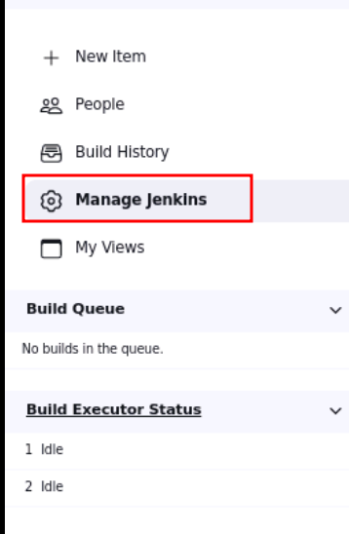

* In the next page click **Manage Plugins.**

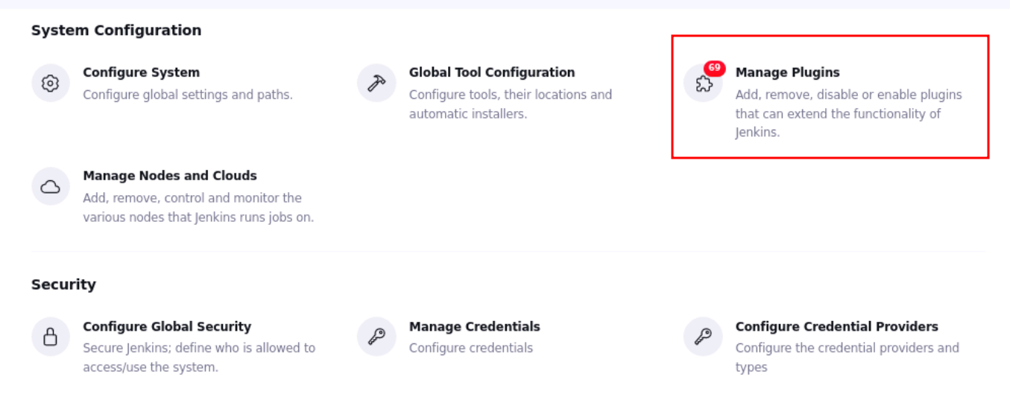

* Click on the Availabletab.

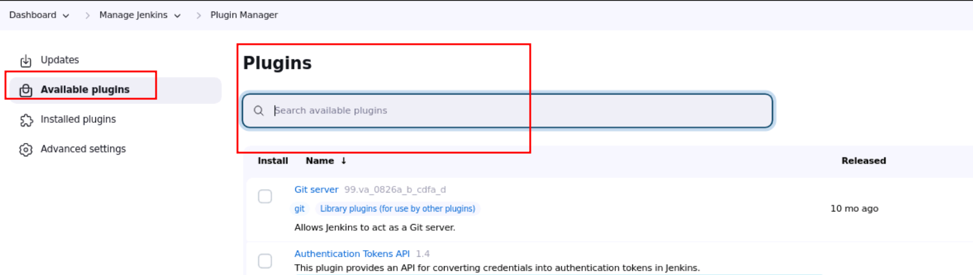

* Check **GitHub Authentication, GitHub Issues.**

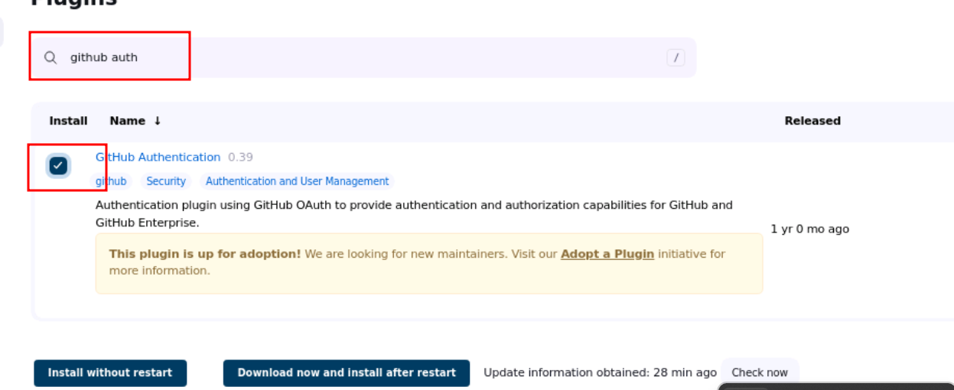

* Check **NUnit.**

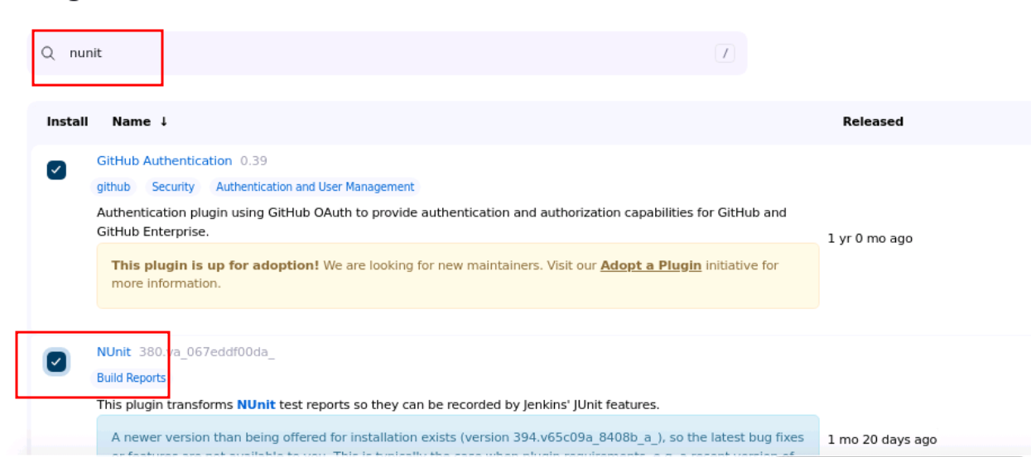

* Check **HTML Publisher.**

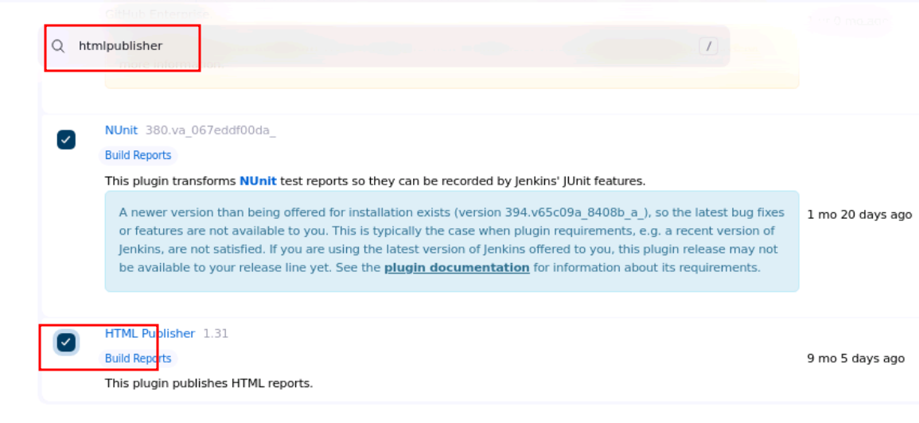

* Check **Node**

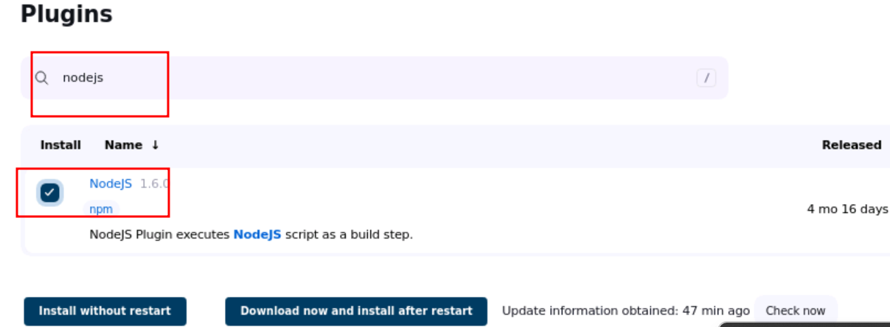

* At the bottom of the page click **Install without Restart.**

**Step 3.1.3:** Pushing the code to your GitHub repositories

Open your command prompt and navigate to the folder where you have created your files.

cd <folder path>

Initialize your repository using the following command:

git init

Add all the files to your git repository using the following command:

git add .

Commit the changes using the following command:

git commit -m “Changes have been committed.”

Push the files to the folder you created initially using the following command:

git push -u origin master